Case Study of Issues with Reclaimed Municipal Wastewater in Power Generation Facility
Author: Danny Engle Course: ENVR 5403 Instructor: Dr. Thayer 12/1/2024

Table of Contents:

Introduction – Page 3 Abstract – Page 4
Regulatory Framework – Page 5 Current Challenges – Page 7 Impact Analysis – Page 10 Recommendations – Page 12 Conclusion – Page 14 References – Page 15 Appendices – Page 16

Abstract
The quality of treated wastewater is critical for protecting public health, supporting industrial operations, and meeting environmental regulations. This document examines the regulatory situation, current challenges, overall impact, and recommendations to solve the problems with using Lawton POTW reclaimed water. There is an ongoing $85 million upgrade
project at the City of Lawton’s activated sludge wastewater treatment plant. This will focus on its impact on the treated water supplied to the Public Service Company of Oklahoma’s (PSO) Comanche Generation Facility. PSO (an operating company of the American Electric Company or AEP) depends on this reclaimed water under an agreement that requires compliance with federal laws, including the Clean Water Act (CWA) and the Safe Drinking Water Act (SDWA). However, data from the Environmental Protection Agency (EPA) indicate episodic exceedances of pollutant limits in the water, raising concerns about the plant’s ability to consistently meet standards.

The study evaluates the challenges faced by the treatment plant, such as seasonal variability in influent and aging infrastructure, and analyzes how the three-phase upgrade project addresses these issues. It also explores how the upgrades aim to improve effluent quality, ensure regulatory compliance, and provide a reliable water supply for PSOPSO. Through a review of the plant’s current processes, planned improvements, and regulatory requirements, this document highlights the importance of investment in wastewater infrastructure to meet environmental and operational demands.

The findings suggest that the upgrades will enhance the plant’s performance and compliance, benefiting both the City of Lawton and PSO. This analysis underscores the significance of effective water resource management in balancing municipal needs, industrial demands, and environmental protection.

Introduction
As part of an environmental mentorship program with American Electric Power (AEP), I was made aware of the topic of the Lawton POTW by my mentor, Dr. Tim Lohner, Manager of Environmental Permitting, to evaluate the challenges and opportunities associated with the City of Lawton’s wastewater treatment plant. Dr. Lohner presented this issue due to my proximity to the PSO operating company area, allowing me to participate in a site visit during the summer of 2024. The evaluation focuses on the ongoing $85 million upgrade project at the Lawton plant and its
impact on the treated water supplied to PSO’s Comanche Generation Facility.

Managing water resources is very important for keeping people safe, protecting the environment, and helping businesses run smoothly. PSO has an agreement with the City of Lawton to buy treated wastewater, also called reclaimed or gray water, from their treatment plant. This water is supposed to be treated and safe to use under federal laws like the Clean Water Act (CWA) and the Safe Drinking Water Act (SDWA). Water quality enforcement is the responsibility of the Oklahoma Department of Environmental Quality (ODEQ)

Recently, workers at PSO’s Comanche Power Generation Facility noticed problems with the water. They found sludge like substances and Total Suspended Solids (TSS) like paper pulp in PSO ponds supplied from treated water from the Lawton POTW which appeared to be left from the treatment process that presented a potentially hazardous situation to operators and that it sometimes had unacceptable water quality, according to data from the Environmental Protection Agency (EPA). These problems are not caused by PSO’s operations due to the source of the pollutants. This is a significant concern because PSO has a permit to release treated water from the Comanche plant into 9 Mile Creek near Lawton, Oklahoma. If the water is not clean enough, PSO could face penalties, and have trouble running their plant which can affect the regional power supply, utility rates, and economic competitiveness.

The City of Lawton’s wastewater treatment plant has had a bad reputation for years because it often struggles to meet water quality standards. To fix these issues, the City is spending $85 million to upgrade the plant. These upgrades include new equipment and processes to help improve the quality of the water. These changes are important to meet the rules of the CWA and SDWA and to make sure the water PSO receives meets the criteria of the Lawton-PSO agreement.

This document looks at the upgrade ideas to consider at the Lawton wastewater treatment plant. It will explain how the upgrades might fix current problems and improve the water quality for PSO. It will also show how these changes can help the City of Lawton follow the rules and keep everyone safe. Unfortunately I could not get detailed information on the planned upgrades and the progress of the project as I am not a direct stakeholder of the Lawton POTW.

Regulatory Framework
The operations of the City of Lawton Publicly Owned Treatment Works (POTW) and the PSO Comanche Generation Facility are influenced by a robust regulatory framework aimed at ensuring environmental compliance and operational efficiency. This framework is shaped by federal, state, and contractual requirements that govern water quality standards, wastewater treatment processes, and resource management.

The Clean Water Act (CWA) serves as the primary federal regulation overseeing the discharge of pollutants into U.S. waters. The City of Lawton POTW operates under a National Pollutant Discharge Elimination System (NPDES) permit issued under the CWA. This permit sets effluent quality standards, including limitations on nutrients like phosphorus and biological oxygen demand (BOD). The water contract between the City of Lawton and PSO specifies compliance with
ODEQ standards and the requirements outlined in the City’s NPDES permit (City of Lawton & PSO, 2021).

PSO’s Comanche Generation Facility indirectly relies on the POTW's compliance with CWA regulations, as the plant uses up to 1.5 million gallons per day of reclaimed effluent for cooling pond makeup water. PSO is also directly regulated by the CWA, with its own NPDES permit governing the discharge of treated water into 9 Mile Creek. The variable quality of incoming effluent from the Lawton POTW poses a compliance concern for PSO. This problem is one of the reasons I was interested in this topic because of interconnectedness of municipal and industrial water management (American Electric Power, 2017; City of Lawton & PSO, 2021).

Although the Safe Drinking Water Act (SDWA) primarily focuses on potable water standards, its principles influence the operation of wastewater treatment facilities that supply reclaimed water for industrial use. The Lawton POTW must ensure its treatment processes minimize contaminants that could affect downstream users like PSO, even though the effluent is not used for human consumption. Ensuring compliance with SDWA-aligned guidelines helps protect public and environmental health, reinforcing the importance of the POTW's upgrade project (American Electric Power, 2017).

State-level oversight by ODEQ plays a significant role in regulating the Lawton POTW. The second addendum to the water contract between the City of Lawton and PSO outlines additional effluent quality requirements, including compliance with ODEQ Title 252, Chapter 627, which governs the operation and maintenance of water reuse systems. The contract also obligates the City to notify PSO within 72 hours of any wastewater permit exceedances, ensuring transparency and allowing PSO to mitigate potential risks (City of Lawton & PSO, 2021).

The regulatory framework requires the Lawton POTW to deliver consistent water quality that meets NPDES permit limits and contractual standards. However, historical challenges with effluent quality—including issues with total phosphorus, BOD, total suspended solids (TSS), and

eutrophication—underscore the need for significant infrastructure upgrades. For PSO, the variability in water quality not only complicates operational management but also increases the risk of non-compliance with its own NPDES permit for effluent discharge (American Electric Power, 2017).
The regulatory requirements governing the City of Lawton POTW and the PSO Comanche Generation Facility demonstrate the complexity of maintaining compliance while balancing municipal and industrial water resource needs. The $85 million upgrade project at the POTW is likely to be a critical step toward meeting these regulatory obligations, ensuring sustainable water quality, and supporting the operational demands of the Comanche Generation Facility. By addressing existing challenges, the project reinforces the importance of adhering to the CWA, SDWA-aligned, and state-level requirements in achieving long-term environmental and operational goals.

Current Challenges

The City of Lawton’s Wastewater Treatment Plant (WWTP) has faced persistent challenges in achieving compliance with environmental regulations, particularly those under the Clean Water Act (CWA). These issues have resulted in multiple Notices of Violation (NOVs) from the ODEQ and highlight the necessity for significant upgrades to the facility. The following sections outline the specific challenges encountered by the WWTP.

- Effluent Quality and Regulatory Compliance

One of the primary challenges has been meeting the effluent discharge limits specified in the National Pollutant Discharge Elimination System (NPDES) permit. The facility has struggled with elevated levels of ammonia and biological oxygen demand (BOD) in its discharges, which have exceeded allowable thresholds (The Lawton Constitution, 2024).

For example in July 2024, the ODEQ cited the WWTP for high ammonia concentrations in its wastewater effluent. Ammonia is a significant pollutant that can harm aquatic ecosystems, particularly in warm weather when oxygen levels in water are naturally lower (Southwest Ledger, 2024).
Historical data have shown episodic violations of total suspended solids (TSS) and total phosphorus limits, further contributing to water quality issues downstream. These exceedances have not only resulted in regulatory penalties but have also undermined trust among stakeholders, including industrial users such as PSO’s Comanche Generation Facility.

- Environmental Impact: Fish Kills and Ecosystem Distress

The environmental consequences of the WWTP’s operational challenges have been notable. In August 2024, during ongoing upgrade efforts, a fish kill was reported downstream of the facility in a local creek (KOSU, 2024). Fish kills are often indicative of acute water quality issues, such as spikes in pollutant concentrations or oxygen depletion caused by excessive organic matter or chemical imbalances.

Such incidents highlight the broader ecological risks associated with the plant’s performance. Local waterways serve as vital habitats for aquatic species, and contamination can disrupt these ecosystems, leading to long-term ecological damage.

- Aging Infrastructure and Capacity Issues

The WWTP’s infrastructure, much of which predates modern regulatory standards, has been identified as a key factor contributing to its challenges. Aging equipment and outdated
treatment processes have limited the plant’s ability to handle variations in influent quality and flow rates effectively. This has been particularly problematic during:

Seasonal fluctuations in wastewater composition, which can overwhelm the plant’s treatment capacity. Storm events, which increase inflow and infiltration, further straining the system and leading to bypasses or partially treated discharges. The outdated infrastructure has also made routine maintenance more challenging, resulting in occasional equipment failures and reduced treatment efficiency.

- Industrial and Community Impact

The WWTP’s operational issues have also affected its relationship with industrial users and the community. For example, PSO’s Comanche Generation Facility, which relies on reclaimed water from the WWTP for its cooling processes, has reported variability in water
quality. This variability complicates PSO’s operations and poses risks to its compliance with its own NPDES permit (PSO, 2017).
Republic Paperboard, a major industrial customer of the WWTP, has noted occasional odors and water quality concerns linked to the plant. In response, the company has committed to a $15 million upgrade of its own wastewater systems (Voith, 2021) and has agreed to reimburse the city for associated costs (KSWO, 2023Re). Community concerns about odor and water pollution have further strained public perceptions of the WWTP, emphasizing the need for transparent and effective remediation efforts.

- Financial Constraints and Funding Needs

Upgrading the WWTP to modern standards requires significant financial investment. The city’s $85 million upgrade project (KSWO, 2024) is a critical step toward addressing these challenges, but it also highlights the broader issue of funding limitations for municipal

infrastructure. Balancing the immediate need for compliance with long-term sustainability remains a financial and logistical challenge for city officials.

The challenges facing the City of Lawton WWTP are multifaceted, spanning regulatory compliance, environmental impact, infrastructure limitations, and industrial relations. While the ongoing upgrade project represents a proactive response to these issues, its success will depend on sustained investment, effective management, and collaboration with stakeholders. Addressing these challenges is essential not only for the WWTP’s regulatory compliance but also for
protecting the environment and supporting the region’s industrial and community needs.

Impact Analysis
The challenges and upgrades at the City of Lawton’s Publicly Owned Treatment Works (POTW) have significant implications for multiple stakeholders, including the PSO Comanche Generation Facility and the broader Lawton community. The plant's historical compliance issues and ongoing modernization efforts represent a pivotal opportunity for improving regional water management, environmental protection, and community relations.
- Impact on PSO Comanche Generation Facility
  - Operational Challenges: The variability in water quality has introduced operational complexities for PSO. Elevated levels of pollutants, including ammonia and biological oxygen demand (BOD), necessitate additional on-site treatment measures to maintain compliance with its National Pollutant Discharge Elimination System (NPDES) permit for discharging into 9 Mile Creek (City of Lawton & PSO, 2021). These measures increase operational costs and reduce efficiency.
  - Regulatory Risks: Episodic violations in effluent quality from the POTW pose regulatory risks to PSO, as non-compliant water entering its processes could result in exceedances in its own discharges. This creates potential for penalties

and reputational harm, even when PSO is not the source of the pollution (American Electric Power, 2017).
  - Strategic Opportunities: The $85 million upgrade project at the Lawton POTW provides an avenue for improved water quality. By reducing pollutant quality, the upgrades are expected to enhance PSO’s operational reliability and reduce the need for reactive management.
The relationship between PSO and the City of Lawton underscores the importance of municipal- industrial collaboration in addressing shared water quality challenges.
- Impact on the Lawton Community
  - Environmental Impact: Episodes such as the 2024 fish kill downstream of the POTW underscore the ecological risks associated with poor wastewater treatment. These incidents harm aquatic ecosystems and diminish public trust in environmental management efforts (KOSU, 2024).
  - Public Health Concerns: Although the POTW does not supply potable water, its effluent contributes to local water systems. Contaminant exceedances, such as elevated ammonia levels, pose potential risks to downstream users and wildlife, reinforcing public concerns about water safety in the region (Southwest Ledger, 2024).
  - Economic Considerations: The financial burden of upgrading the POTW— estimated at $85 million—is substantial. However, failure to address the plant’s deficiencies could lead to greater costs, including fines, reduced industrial
activity, and harm to the community’s quality of life. For instance, Republic Paperboard’s commitment to a $15 million upgrade of its own wastewater systems and reimbursement of $100,000 to the City highlights the shared responsibility among stakeholders (KSWO, 2023).
The performance of the WWTP impacts local businesses and residents alike. Improvements in wastewater treatment will enhance the community’s trust and improve living conditions.
- Broader Regional Implication
  - Enhancing Regional Resilience: Upgrades to the POTW could position Lawton as a model for balancing environmental compliance with industrial needs.

  - Improving Stakeholder Collaboration: Partnerships between PSO, Republic Paperboard, and the City of Lawton illustrate the importance of joint efforts in managing water resources effectively.
  - Fostering Economic Development: Reliable wastewater treatment is a cornerstone for attracting businesses and fostering growth. Improving the POTW strengthens Lawton’s appeal as a location for industrial and economic expansion.

Recommendations
The challenges faced by the City of Lawton’s Publicly Owned Treatment Works (POTW) and its implications for stakeholders such as PSO highlight the need for targeted recommendations. Addressing flood risks at the POTW and enhancing monitoring of water quality at PSO's intake point are essential measures for ensuring sustainable operations and environmental compliance. These are mainly from my personal evaluation during a site visit, and follow-up analysis of GIS data.
- Flood Mitigation for the Lawton POTW: The Lawton POTW’s location at 34.52803,
-98.36742 places it within a 100 year flood-prone area, posing risks to its infrastructure and operations during extreme weather events. Flooding can lead to untreated or partially treated wastewater being released into surrounding water bodies, exacerbating environmental and public health concerns. To mitigate these risks, the following measures are recommended:
  - Elevation of Critical Infrastructure: Key components of the wastewater treatment process, such as pumps, electrical systems, and chemical storage, should be elevated above the 100-year floodplain level. This would reduce the likelihood of damage during flooding events.
  - Flood Barriers and Levees: Installing permanent flood barriers, levees, or berms around the facility can provide physical protection against rising water levels.

  - Storm water Management Enhancements: Improving on-site drainage systems and incorporating retention basins can help manage excess water during heavy rainfall, reducing the risk of flooding within the facility.
  - Floodproofing Measures: Structural floodproofing, such as sealing walls and installing backflow prevention valves, can prevent water intrusion and protect critical equipment.
  - Relocation of Vulnerable Components: As part of the planned upgrades, relocating portions of the POTW to higher ground or constructing new facilities outside the flood zone should be prioritized. This long-term solution aligns with the $85 million upgrade project’s goals.
- Implementation of a Monitoring System at the PSO Intake Site: Given the variability in water quality from the Lawton POTW, it is recommended that PSO establish its own monitoring system at the intake site where effluent is pumped to the Comanche Generation Facility. Such a system would provide real-time data on key water quality parameters, allowing PSO to respond proactively to fluctuations and ensure compliance with its own discharge permits. Specific recommendations include:
  - Installation of Continuous Monitoring Equipment: Real-time sensors for parameters such as ammonia, total dissolved solids (TDS), temperature, and pH should be deployed at the intake point. These sensors would provide continuous data, enabling immediate detection of deviations from acceptable levels.
  - Data Integration with Plant Operations: The monitoring system should be
integrated into PSO’s existing operational framework. Automated alerts could notify operators of potential issues, facilitating swift corrective actions.
  - Sampling and Verification Protocols: In addition to real-time monitoring, periodic manual sampling should be conducted to verify sensor accuracy and provide a more comprehensive assessment of water quality.
  - Collaboration with the Lawton POTW: Sharing monitoring data with the POTW could improve transparency and accountability, fostering a more collaborative approach to addressing water quality challenges.

  - Long-Term Data Analysis: Over time, the data collected can be used to identify trends and patterns in water quality, supporting predictive maintenance and strategic planning for both PSO and the POTW.
By implementing these recommendations, PSO can safeguard its operations against the risks associated with variable water quality while enhancing its environmental stewardship.

Conclusion
The City of Lawton’s Publicly Owned Treatment Works (POTW) is at a critical juncture, where its historical challenges with compliance and infrastructure limitations intersect with significant investment in upgrades. The $85 million multi-phase modernization project represents a transformative opportunity to address these long-standing issues, improve effluent
quality, and enhance the facility’s operational resilience. However, the success of these efforts hinges on a collaborative approach among stakeholders, robust flood mitigation measures, and continuous monitoring to ensure sustainable outcomes.

For PSO’s Comanche Generation Facility, the variability in water quality from the Lawton POTW underscores the need for proactive strategies. By implementing a dedicated monitoring system at the intake site, PSO can better manage risks associated with pollutant fluctuations and ensure compliance with its own discharge permits. This system would not only safeguard PSO’s operations but also serve as a model for industrial users relying on municipal wastewater systems. Collaboration with the City of Lawton to share data and address emerging challenges could further strengthen this partnership and promote mutual accountability.

From a community perspective, the upgrades to the POTW are essential for restoring trust in local environmental management. Addressing flood risks through structural and operational improvements will protect public health, prevent ecological harm, and demonstrate the city’s commitment to responsible stewardship. Moreover, enhanced wastewater treatment

capacity and reliability will support economic growth by attracting and retaining industrial stakeholders like PSO and Republic Paperboard. These investments ensure that the Lawton community can thrive in a sustainable and environmentally responsible manner.

In summary, the modernization of the Lawton POTW represents a pivotal opportunity to resolve systemic challenges and set a standard for effective municipal-industrial collaboration. By integrating advanced infrastructure, rigorous monitoring, and strategic flood mitigation, the City of Lawton and its partners can achieve compliance with regulatory standards, protect local ecosystems, and secure a sustainable future for the region. Through continued investment, transparent communication, and shared accountability, the outcomes of this project will benefit all stakeholders for years to come.

References
American Electric Power. (2017). Comanche Power Station Case Study.

City of Lawton & Public Service Company of Oklahoma. (2021). Second Addendum to Water Supply Contract.
Southwest Ledger, 2024. https://www.southwestledger.news/news/lawton-wwtp-cited-again- deq-significant-progress-being-made
The Lawton Constitution, 2024. https://www.swoknews.com/news/lawton-cited-for-high- ammonia-levels-in-wastewater-discharge/article_c4178f57-3ea7-5c4f-b59d-684290eee8c2.html
KOSU, 2024. https://www.kosu.org/energy-environment/2024-08-05/as-lawton-works-to-fix-its- wastewater-treatment-plant-officials-find-fishkill-downstream
Voith, 2021. https://voith.com/corp-en/P-CurtainCoater-PR-210210.pdf

KSWO, 2023. https://www.kswo.com/2023/03/02/republic-paperboard-company-reimburse-city- lawton-local-plant-upgrades/
KSWO, 2024. https://www.kswo.com/2024/04/10/city-lawton-addresses-wastewater-dumping- allegations-east-cache-creek/

Appendices
FEMA 100 YR FLOOD MAP OF LAWTON POTW AND PSO COMANCHE FACILITY
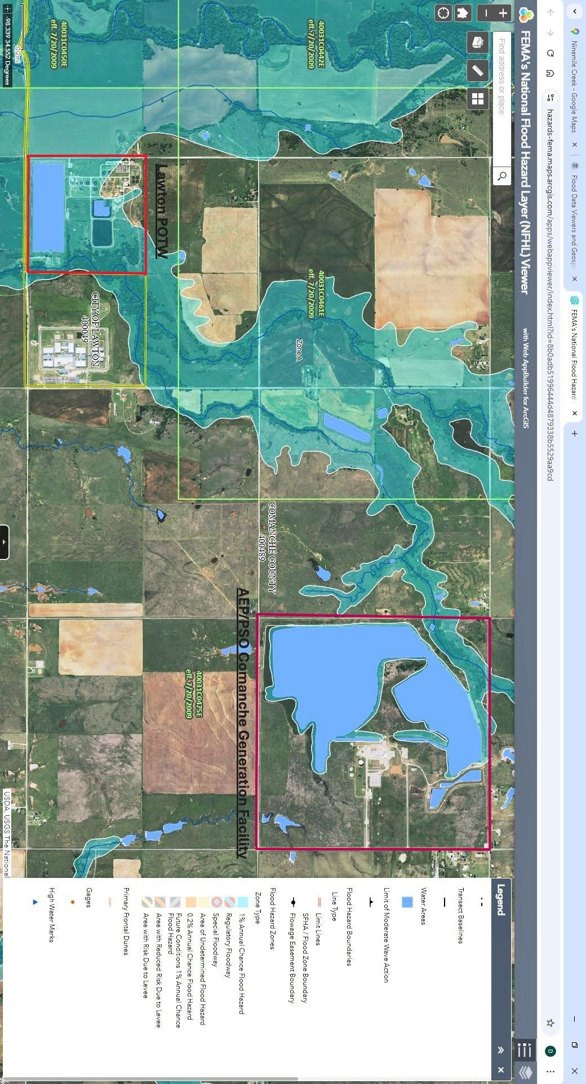

CITY OF LAWTON AND PSO WATER QUALITY 2021 AGREEMENT
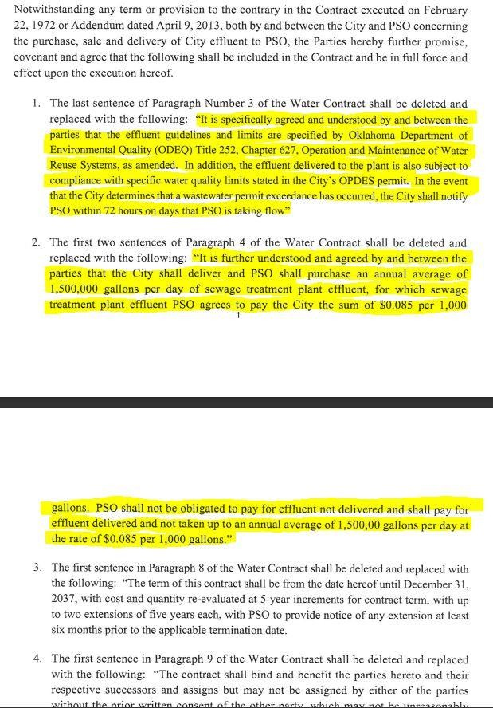

PSO 2017 CASE STUDY
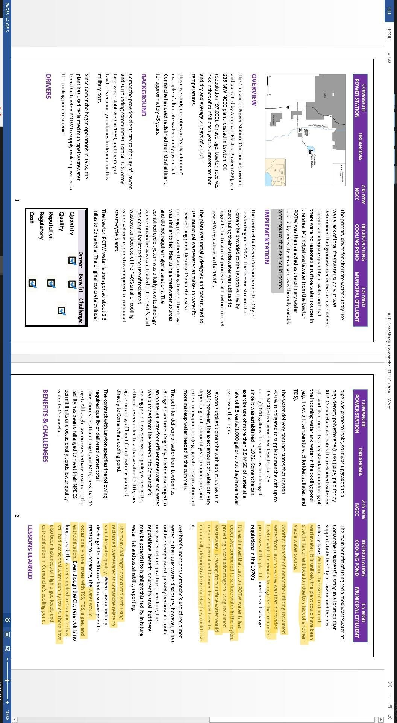

CITY OF LAWTON NOV
